Mechanical Work - W
Physics quantity equals to the product of the magnitudes of the force component along the direction of displacement and the displacement.
Work is not done, if:  - The force applied but the object doesn’t move.  For example: ___________________________________________ .  - An object is moving but resultant force equals zero.  For example: ___________________________________________  - _________________________________________________  For example: _____________________________________________ | 1.  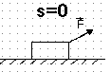
2.
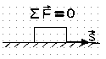
3.
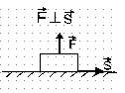
Work is done if:  The force has the same direction as the displacement  (α=_____, cos ______), then ____________________ | 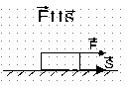
The force has the opposite direction to the displacement  (α=____, cos ____), then ____________________ | 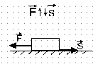
If the angle between force and displacement 0⁰ < α < 90⁰, then work is ___________________________________. | 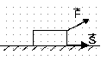
If the angle between force and displacement 90⁰ < α < 180⁰, then work is ________________________________________. | 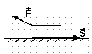
If several forces applied to an object the net work equals to work done by the net force.
Interpret work graphically:  The area of rectangle below the graph F(x) equals work done by a force F during object’s motion from the point х₁ to the point х₂. | 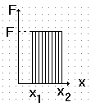
The SI unit of work
[W] = N •m=J , Joules  The work equals 1 J, if the 1-N force applied to a body makes it move 1 m. | 1J = 1N • 1m

